**Exploratory Analysis of Expert Predictions in College Football**

**Submitted to:**

Cole Reagan

*Gameday Cole*

**Report Prepared by:**

Won Ha Gonzalez

MASDA Student, Department of Statistics

Southern Methodist University: Dallas, TX 75205

Owen Lin

MASDA Student, Department of Statistics

Southern Methodist University: Dallas, TX 75205

December 17, 2019

**Table of Contents**

Executive Summary …………………………………………………………… i

Introduction ……………………………………………………………………. 1

Statistical/Executive Methods …………………………………………………. 2

Results …………………………………………………………………………. 6

Conclusion ……………………………………………………………………... 8

Appendix ………………………………………………………………………. 11

**EXECUTIVE SUMMARY**

College football takes a prominent role in the success of college sports as an entertainment product. Media entertainment products also developed around the sport: Shows like *College Gameday* are popular among college football fans. Part of the entertainment value provided by these types of shows is expert analysis and the predictions made by the expert analysts.

As part of the analysis, the client provided expert predictions data and an additional source for us to collect gambling data. The gambling data provided money lines for college football games from the 2007–2008 to the seventh week of the 2019–2020 season, and the expert predictions data started in the 1989–1990 and continued to the 2019–2020 season. The full data set consisted of 23,517 observations and 113 experts.

On analysis of the data, prediction rate trends indicate the assumed idea that the winners are more difficult to predict in more competitive games. The 50th percentile of correct prediction rate when the home- and- away-teams money line differed by 500 or less is 54%. The 50th percentile of the rate when the games’ with a money line difference of 1500 or less is 62%.

When we weighted the value of the expert predictions, analysis indicates that a majority of the correct picks result from the experts picking the favorites for a game. Correct picks were weighted based on the difficulty of correctly picking that winner. Win percentages clustered from about 55% to about 75%. However, the average points earned by analysts from about 0.15 points to about 0.35 points (with 1 being the highest points earned possible for a correct pick).

**Introduction**

Given sports have become incredibly popular and have become a billion-dollar industry, with the potential to expand into other industries. One such area is that of entertainment. And as a part of the college-sports landscape, college football is particularly valuable, bringing in $1.7 billion dollars of profit for its top division, Football Bowl Subdivision (Novy-Williams 2017).

Because college football has so much financial potential as an entertainment product, television and network shows naturally developed to broadcast experts who analyze college football games before and after the events. One of these shows, *College Gameday*, which is broadcast on ESPN, became a leading example of the entertainment potential in college football. The entertainment value provided by *College Gameday* includes its panel of expert analysts, who often have played or coached college football. All pre-game analyses is highlighted by the prediction of the winner by the panel of experts. These predictions occur in entertainment media: analysts from other outlets and college football writers often make predictions as well.

The analysis and predictions of college football games and players seems endless; however, little research evaluates how well the analysts predict the outcomes of college football games. Research can measure accuracy and thus determine whether and at what rate analysts’ predictions are correct and incorrect. Therefore, using analysts’ predictions data collected since 1989, we analyzed the experts’ predictions to determine the quality of their predictions.

Fans who are familiar with college football could argue that predictions are not all equal: some matchups are competitive, and some games are not. Therefore, in analyzing predictions, we determined to evaluate if evidence exists to show that more competitive games are more difficult to predict. We also sought to determine how valuable experts are in making their predictions.

We conducted an exploratory analysis to address these questions. Below, we find that the assumptions that more competitive games are more difficult to predict correctly. We also explain gambling terminology and how gambling data is used to provide more insight in what types of games experts are picking correctly. We find that most of the value of an expert’s pick come from correctly picking the favored team.

**Statistical/Exploration Methods**

We analyzed the client-provided data, which can be seen in blog entries on the *Gameday Cole* website. When we started this analysis, the game and prediction data spanned from the 1989–1990 college football season to Week 7 of the 2019–2020 season. This data set includes 23,517 game observations, predictions from 113 analysts, and the results of the game. However, more data needed to be incorporated into the dataset and analysis so we could determine if some games are more difficult than others to predict and determine the value of the analysts’ predictions.

Per the client’s advice, we used “money line” gambling data in order to expand the dataset and thus be able to determine the quality of matchup that each game provided. (These money lines are used as a system to calculate the rewards for bets.) The gambling data spanning from the 2007 to the 2019–2020 season comes from [www.sportsbookreviewsonline.com](http://www.sportsbookreviewsonline.com): the data lists the date of a game, the two teams playing, and the money lines.

Data cleaning and processing accounted for a large portion of the work that went into putting this analysis together. The layout of the money-line datasets placed each team in an individual row of the .csv file. The visiting team of a game is listed in the first row and the home team of a game is listed in the second row. Each team is given a money line value. Each of the gambling datasets also included various other gambling information, the scoring information for each team during the game, and the date of the game was held. We take only the money-line gambling data to use for this analysis. Each two rows represented a single game. In order to be able to merge the gambling data into the client’s dataset, the gambling dataset for each year had to be transformed into a usable dataset. We reformat the gambling datasets so that each game serves as a single observation (occupying one row). In order to merge each year of gambling data together, we needed to code the year into the datasets, as the year was missing in each of the datasets. We then merge all the various years of gambling data into a single money-line data. We then needed to make sure that the team names in the gambling data matched with the team names in the client’s dataset. We then merged the combined money-line dataset with the client’s dataset.

The money lines report which team is favored and how much they are favored (see Figure 1). The money lines are calculated using $100 as a base line. For example, in Figure 1, the value of -250 indicates that Utah is favored. If betting on Utah to win, a gambler would need to bet $250 to in $100, for a total payout of $350. If the gambler selected Oregon to win, the +200 value indicates a $100 bet would win $200, for a total payout of $300.

*Figure 1: Example of a Money Line*

The money-line data provide information on who is favored to win and the scale to which the team is favored. For example, if the favored team is 500 more than an unfavored (“underdog”) team, the money line indicate a that bookmakers believe the favorite is approximately 7 games points better than the “underdog” (the difference in game points is referred to as “the spread). A difference of 1000 in money line indicates a difference of approximately 14 game points, and a difference of 1500 in money line indicates a difference of approximately 17 game points. These differences were inferred from observing weeks of money line and spread data (Bet QL).

For this analysis, we used these differences in money lines as subsets to determine if correct prediction rates of experts differed for “competitive” and “non-competitive games” —that is, were the teams equally matched and thus likely to finish with a close final score. We assumed that correct prediction rates would increase as games with larger differences in money lines were included in the analysis. Games for which the money lines were 500 or less would be more difficult to predict than were games with money lines that differed by 1000 or less. (We provide our conversion equation in Figure 2.)

*Figure 2: Money Line Conversion to Win Probability*

Favorite with a money line of – 120:

$$\frac{|-120|}{\left|-120\right|+100}= \frac{120}{220}= .545$$

Underdog with a money line of 180:

$$\frac{100}{180+100}= \frac{100}{280}= .357$$

We anticipated that money-line data also would provide information on a team’s implied probability to win. The win probability conversion formula depends on whether a team is the favorite or the “underdog” —that is, the team that is expected to lose. Because a conversion formula exists for win probability, we used the win probabilities to weigh the value of a correct prediction (Betting Expert). We chose to use the win probability of the winning team and subtract that from 1 (demonstrated in Table 1). For example, if a team had a 75% chance of winning and did win, we rewarded the source that correctly predicted that win with 0.25 points:

$$1- .75= 0.25 points awarded$$

If an underdog had a 20% chance of winning and did win, we rewarded the source of the correctly picked win with .8 points.

$$1- .20= 0.8 points awards$$

*Table 1: Potential Points Awarded for Correct Picks*

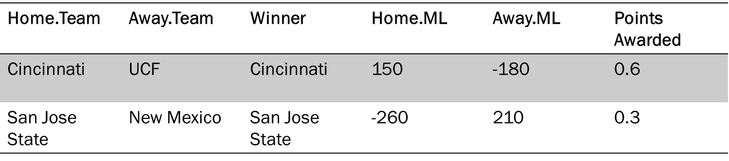

Using this method, analysts can be awarded for correctly making difficult picks, whereas not being given the same credit for making easier (more obvious) predictions.

**Results**

A clear trend develops per differences in the subsets that are created, based on the differences in money lines for games. When we looked only at games with a money-line difference between the favorites and underdogs of 500 and less, the analysts’ correct prediction rate at the median is approximately 54%, the 25th percentile is approximately 49%, and the 75th percentile is approximately 57% (see Figures 3 and 4). The results indicate that experts may be only slightly more accurate than is a coin toss at predicting competitive games defined at difference in money line between favorites and underdogs of 500 or less.

When looking at all games with a money line difference of 1500 or less, analysts show greater success. The median correct rate is approximately 62%, with a 25th percentile of approximately 58% and a 75th percentile of approximately 65%.

*Figure 3: Box Plot Comparison of Correct Prediction Rate by Money Line Subsets*

*Figure 4: Bubble Plot Comparison of Correct Pick Percentage and Average Points Awarded*

When the entire data set is considered, the analysis indicates that experts are more likely than not to correctly predict game outcomes. However, a majority of the expert analysts’ correct predictions come from selecting the favorite team in a game. That is, most analysts cluster from a 55% to 75% correct rate (see Figure 4). The value of most of the experts’ predictions, however, come from the fact that in many instances they are correctly choosing the already established favorites to win. This value is shown by the fact that the average points awarded to the analysts cluster near 0.15 to 0.35.

As stated above, without the money-line data, we give equal credit for analysts correctly picking the favorites to win as we do for analysts correcting picking the “underdogs” to win, although underdogs are less likely to win. The money-line data allows a more refined analysis process; that is, correctly predicting “underdogs” to win resulted in >0.5 points awarded, while correctly predicting already established favorites (expected winners) to win resulted in <0.5 points awarded. Without the money-line data to weight predictions, the correct predictions rates are skewed. Using this as context, we find that highest points earners on average, (Dan Hawkins–0.79 and Clint Stoerner–0.76) have more valuable picks, as they are often predicting “upset” wins that are more difficult to predict. However, with this merged data, the clustering at 0.15 to 0.35 shows that a great deal of points earned by most analysts are from picking favorites.

We also created an interactive application using the Shiny library so the client can see how well experts picked college football games. The Shiny application can be run after running all of the code we provide from the analysis. The client will see the correct prediction rates of experts broken down into three different bubble plots, based on the subsets created by the difference in the favored and “underdog” team money lines and the number of predictions made. Additionally, the client will find another bubble plot that shows both the correct prediction rate of each analyst and the weighted average points earned, accounting for the number of predictions made. A separate tab was created to allow the client to see the final dataset in the Shiny application.

**Conclusion**

By analyzing college-football game-outcome predictions and gambling data, we determined that the assumption that more competitive games are more difficult to predict is likely to be a correct assumption. By integrating the money-line data, we expanded the variables to create a system to value, analyze, and determine an experts’ correct predictions. Exploratory analysis indicates most of the value of an expert’s correct predictions come from correctly selecting the favored team to win. This process is not necessarily negative, as the favored teams are expected (and predicted) to defeat the “underdog” a majority of the time. However, with expanded data, a nuanced view of the average points earned provides greater insight into which analysts are better at predicting underdogs to win games.

Future research may consider under what conditions experts select underdogs to win and how often they are correct when selecting underdogs. Additionally, group research can be conducted to compare different types of experts (those who report via television versus print, *Gameday* versus other shows, etc.). More research should also consider gambling data to determine whether a game is closely matched or not.

Predictive analysis may also be conducted on the future, based on the information we have about how well individual analysts predict games.

The challenges with future research analysis are influenced by the availability and the complexity of the datasets. We noted this challenge because the study included 113 analysts and the number of the predictions ranged from 1 (Mike Stoops and Trey Wingo) to 6211(Phil Steele) for individual analysts (see Figures 4 and 5). As stated above, we see that as games are more competitive, the games are more difficult to predict correct. Thus we see that most weighted points earned by experts cluster from 0.15 to 0.35. The range in the number of predictions most likely affects the overall analysis because the data varies and those who made only a few predictions will likely have either high or low correct percentage rates and weighted points earned. As can be seen in Figure 4, there are some outliers in both prediction percentage and points earned. Some of these outliers are due to the expert only have a few predictions.

*Figure 5: Histogram of Number of Predictions Made by Experts*

Additionally, little data exists to evaluate how well experts predict the outcomes of college-football games. The datasets used in this study came from the client, who painstakingly scoured archived information through various publications to find expert predictions. More data, including information on specific analysts and their predictions, will help future research.

The addition of gambling data is valuable because it adds value to the predictions that experts make. However, many gambling tools are not intuitive and require that the investigator understand systems and variables, such as spreads and calculations, in gambling.

**Appendix**

*Figure 6: Scatter Plot of Correct Pick Percentage for Games with Difference in Money Line of 500 or Less against Number of Predictions Made*

*Figure 7: Scatter Plot of Correct Pick Percentage for Games with Difference in Money Line of 1000 or Less against Number of Predictions Made*

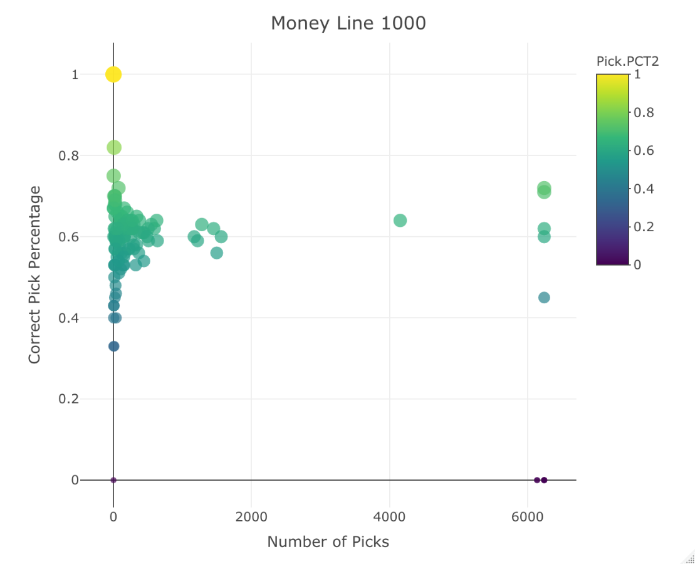

*Figure 8: Scatter Plot of Correct Pick Percentage for Games with Difference in Money Line of 1500 or Less against Number of Predictions Made*

**References**

*Bet QL NCAA Football*. (2019). Retrieved from <https://betql.co/ncaaf>.

*Betting Expert.* “Betting Fundamentals: Learning Betting.” Data retrieved from <https://www.bettingexpert.com/academy/betting-fundamentals/betting-odds-explained#gref>.

Novy-Williams, Eben. (2017). Quicktake: College Sports. *Bloomberg*. Retrieved from <https://www.bloomberg.com/quicktake/college-sports-ncaa>.

Reagan, Cole. *Gameday Cole*. (2019). <https://gamedaycole.com/>

*Sports Betting Review Online*. (2019). Data retrieved from <https://www.sportsbookreviewsonline.com/scoresoddsarchives/ncaafootball/ncaafootballoddsarchives.htm>